Name
Instructor
Course
Date

Consumption after COVID-19
Introduction
COVID-19 pandemic has led to an unprecedented consumption effect across countries that overturned long-standing consumer behaviors. Consumer spending is a significant economic activity, which collapsed as the pandemic ravaged countries early last year. This occurrence forced consumers to reinvent their spending habits. Contrastingly, companies were forced to rethink and transform their business models, whereas governments were obligated to adjust regulations to cushion their citizens. Although the Covid-19 pandemic has affected individuals and regions in infinitely different ways, the economies' effect has been utterly uneven. Employees who have performed their duties from home have maintained their positions and pay, accruing more savings. In contrast, others lost their jobs and were forced to cut back on expenditure such as travel restrictions, lockdowns, and health fears (Chauhan and Shah 0992). The literature will expound on consumer spending after Covid-19
Although there are reasons to be positive for a robust recovery in consumer spending behavior post-COVID-19 due to suppressed demand and substantial amassed savings, like many other disasters experienced in the past, the pandemic will leave permanent marks. Therefore, understanding what this effect means for consumer behaviors and the recovery in their spending habits is a critical factor towards the global economic rescue (Mehta et al. 293). A reflection of divergent sentiments is expected and reflected in the spending extent among consumers. Consumers are expected to shift their expenses to essentials while cutting back on a majority of discretionary goods. Consumers worldwide have reacted to this pandemic and the disruptions associated with it by reverting to normal consumer habits. This means that they try out different shopping behaviors expressing a high determination to incorporate these habits moving forward.
Additionally, consumption post-COVID-19 has been dramatically influenced by commodity pricing, given the consumer's expense thoughtfulness and communism. The other top-cited drivers for consumer decisions are availability and convenience. However, purpose and quality are equally important when consumers choose new brands (Mehta et al. 298).
Remarkably, some chances post COVID-19 economies will fundamentally differ from what preceded them the more prolonged the pandemic lasts and becomes more intense and profound. If the consumer price index is altered, then this may have an impact on consumer preferences. With a shift in consumer preferences in response to the pandemic, some sectors and firms are likely to shut down completely (Zwanka and Buff 59). In this case, these economies are more likely to enter a recession. Trying to support these firms fiscally on a rolling basis will eventually formulate unsustainable sectors and mismatch joblessness.
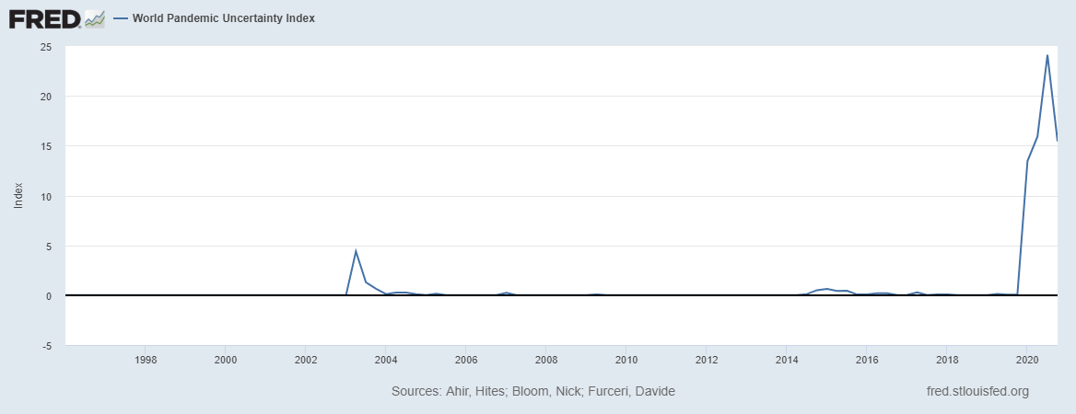
Consequently, concerns are rising due to the existing uttermost liquidity present in liability markets and the supplementary commercial debt projection that continues to build up. A recent study conducted in a sample of 1500 families in Spain, France, Germany, Netherlands, and Italy asking them their post-COVID-19 consumption habits in five significant sectors, namely; services, retail, public transport, tourism, and hospitality, indicated a substantial reduction of consumption across all industries (Zwanka and Buff 61). They explained that the principal reasons behind the decrease in expenditure were financial constraints, lack of Assurance and uncertainty in the future encouraged a rise in cautionary disposable income savings (See fig.1).
Figure 1: World Pandemic Uncertainty Index.
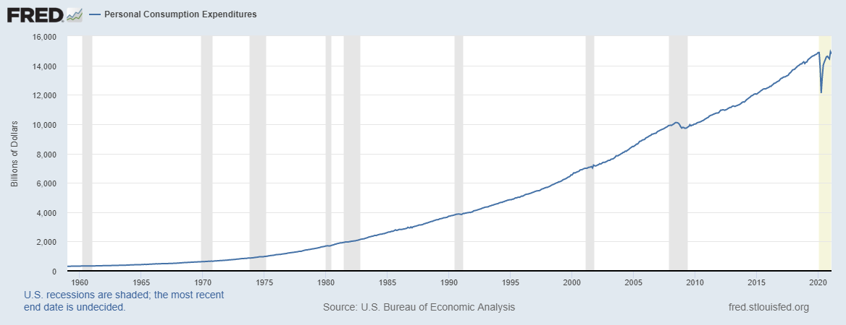
Embracing online options, risks of infection and lasting shifts in preferences resulting from lockdowns were also among their reasons. Similarly, this occurrence has also been experienced in the United States, seeing a reduction in personal consumption expenditures immediately after the pandemic hit (see fig.2).
Figure 2: Personal Consumption (PCE).

It is essential to reflect upon how consumers perform their purchases beyond how much clients are consuming. A significant number of the research subjects indicated that the reduction of shopping at stores and malls was attributed to online options availability. Therefore, as the pandemic becomes persistent, consumers become habituated to this new wave of consumption, which in the long run could lead to a shift in the retail zone away from physical shops. Subsequently, the fraction of consumers reporting a reduction in their expenditure habits than before the COVID-19 pandemic outbreak is somehow associated with the number of deaths and personal infection experiences. Kim used the profit regression models and established that gender is the only socioeconomic consumer characteristic significantly and consistently related to consumption variations (215). Besides, average socioeconomic consumer characteristics like age, income, employment positions, and education play an insignificant role. Instead, behavioral aspects such as psychological influences and macroeconomic expectations are influential illustrative factors influencing the drop in consumption across the sectors.
Conclusion
Notwithstanding the latest positive vaccine milestone and drive, indeed, the risk of infection will still exist for some time. Nevertheless, governments should begin plotting policy paths out of the pandemic and in the direction of a new post-COVID-19 equilibrium. Policymakers should keep in mind two factors to ease the transition. First, the indicators of long-term changes from the research should aid as a caution against upholding broad-based parallel fiscal funding to businesses for a prolonged period (Baker et al. 843). Consumer habits and preferences are likely to change given the level of shock and the understanding of the experience. Therefore, the post-pandemic equilibrium shift requires other obsolete companies to leave the market, specifically those with fewer consumer interests that may encourage deflation to allow the reallocation of funds into segments that better echo consumer demand. Secondly, governments should seize their dual objectives of conserving economic prosperity and protecting their citizens from the risk of viruses as a trade-off until the health emergency has been contained. Baker et al. (851) suggest that governments should focus more on controlling infection threats as a requirement to cost-effective protective prosperity.

Works Cited
Chauhan, Vilas, and Ms Heer Shah. "An Empirical Analysis into Sentiments, Media Consumption Habits, and Consumer Behaviour during the Coronavirus (COVID-19) Outbreak." Purakala with ISSN (2020): 0971-2143.
Baker, Scott R., et al. "How does household spending respond to an epidemic? Consumption during the 2020 COVID-19 pandemic." The Review of Asset Pricing Studies 10.4 (2020): 834-862.
Kim, Rae Yule. "The Impact of COVID-19 on Consumers: Preparing for Digital Sales." IEEE Engineering Management Review 48.3 (2020): 212-218.
Mehta, Seema, Tanjul Saxena, and Neetu Purohit. "The New Consumer Behaviour Paradigm amid COVID-19: Permanent or Transient?." Journal of Health Management 22.2 (2020): 291-301.
Zwanka, Russell J., and Cheryl Buff. "COVID-19 generation: A Conceptual Framework of the Consumer Behavioral shifts to be caused by the COVID-19 Pandemic." Journal of International Consumer Marketing 33.1 (2021): 58-67.

